# How to import environmental responses from AquaMaps

Applies to EwE version 6.5 and newer

Environmental response functions for the Ecospace habitat foraging capacity model can be imported from AquaMaps via the following steps:

1. Navigate to [AquaMaps](http://www.aquamaps.org/) and search for the species that you are interested in
2. Click the scientific name of the species of interest:  
     
   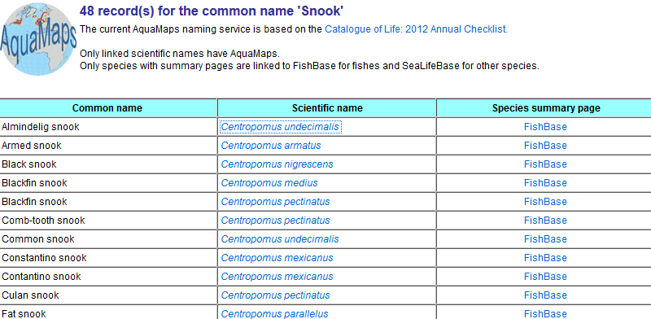
3. In the generated distribution map, click “Download native range data”:  
     
   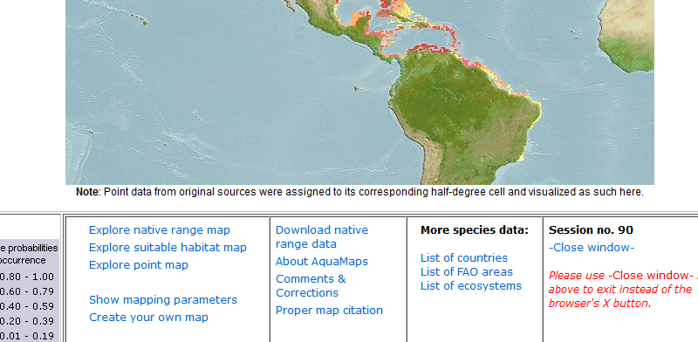
4. AquaMaps now wants to know what format you want this data in. Select “Environmental Data (HSPEN)” and a CSV file will be prepared for you. Download the file to your computer
5. Now, in EwE, have an Ecospace scenario loaded, and select “Import AquaMaps HSPEN species envelopes” from the tools menu:  
     
   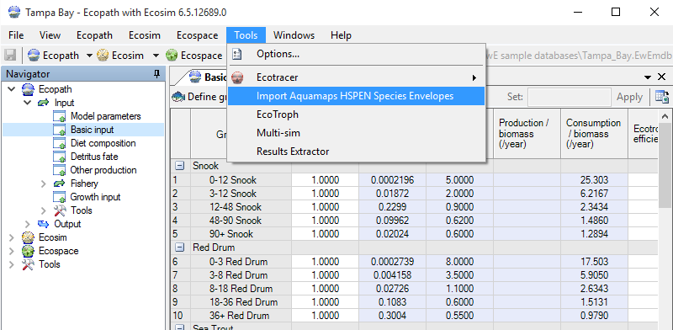
6. Select or drag/drop the downloaded HSPEN CSV file onto the Import form. Check the envelopes that you wish to import, and the species that you wish to import this data for. To start the import process, press the [Import] button:  
     
   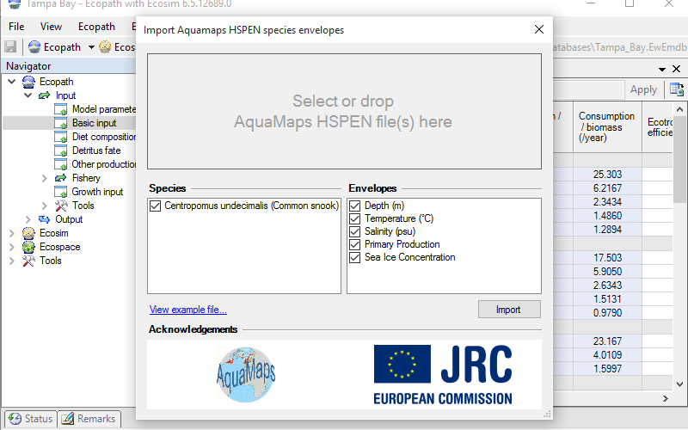
7. The response functions are now imported into Ecospace, with names automatically generated from AquaMaps Envelope + Species. The EwE status panel will display which response functions were successfully imported.  
     
   Close the import form. The newly imported environmental response functions are now visible in Ecospace > Input > Habitat based foraging:  
      
   